Assignment 1: Student Portal — Courses & Enrollments
- List all databases, then switch to `college_portal`.
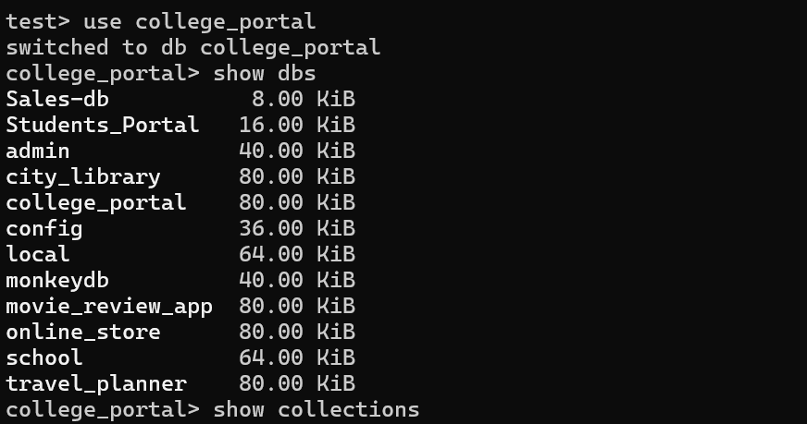
- Display all collections in this DB.
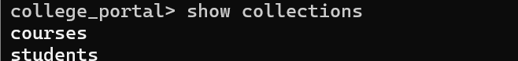
- Show all students.
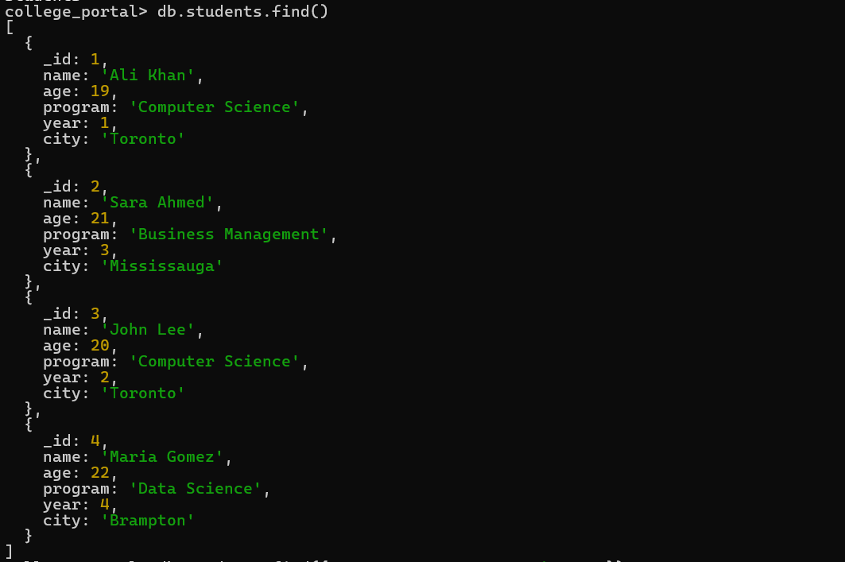
- Find all **Computer Science** students.
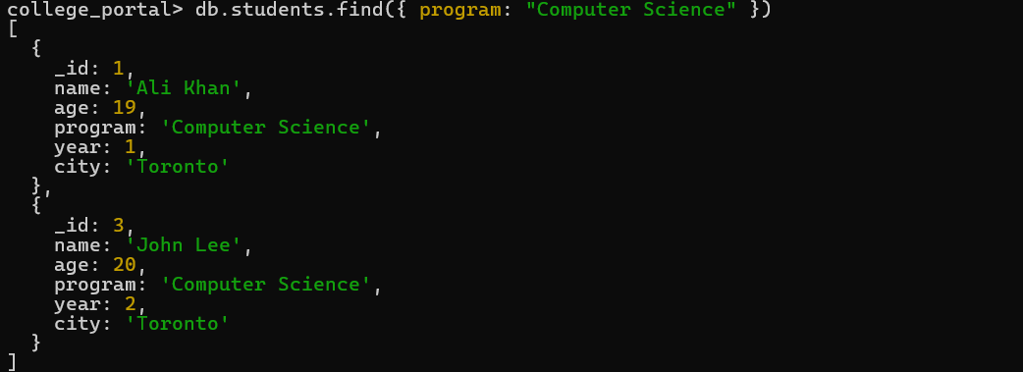
- Find students from **Toronto** who are in **year 2 or above**.
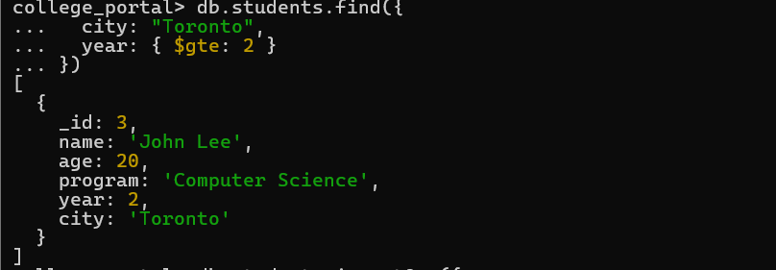
- Add a new student in the `students` collection (any realistic data).
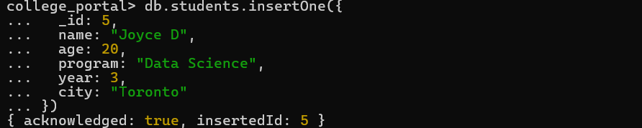

- Update **Ali Khan** to set a new field: `"isScholarship": true`.

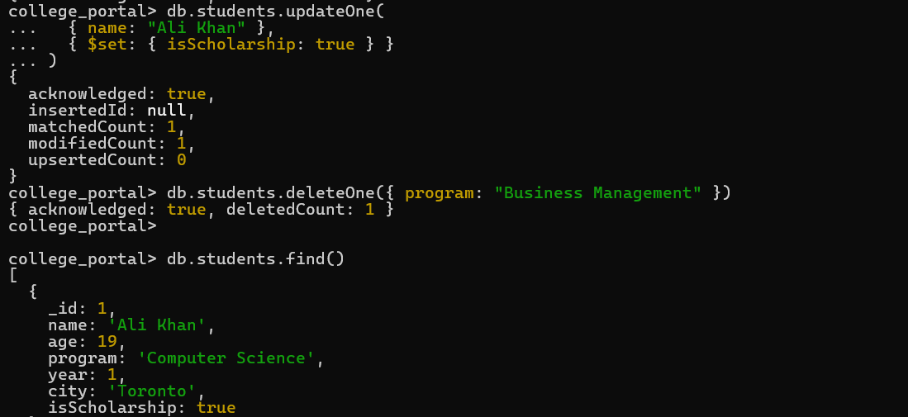
- Delete one student record where `program` is `"Business Management"`.
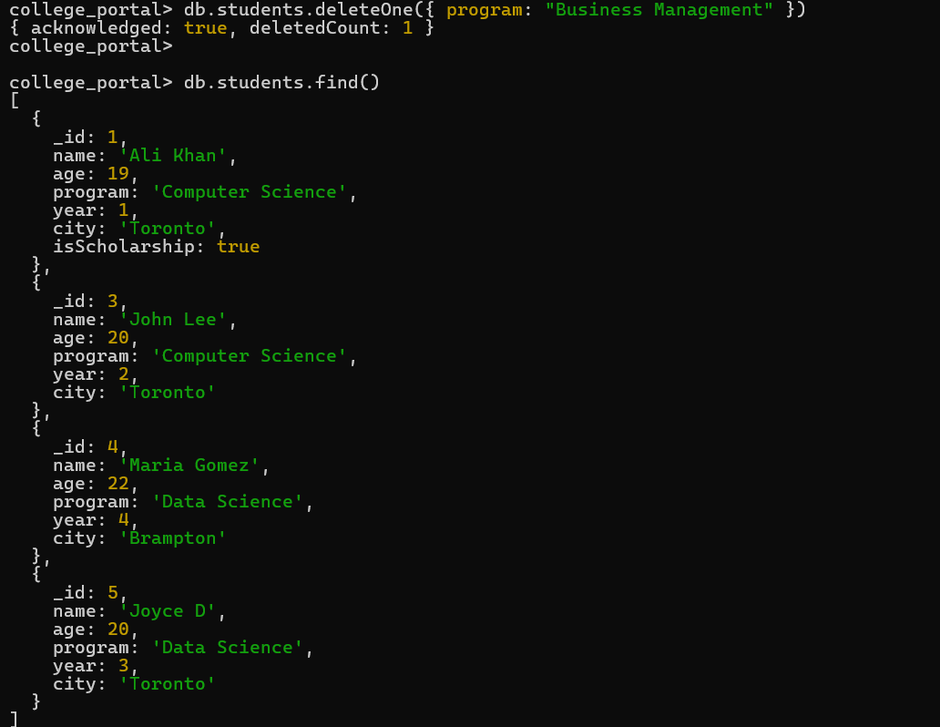
- Find all courses with `credits >= 3`.
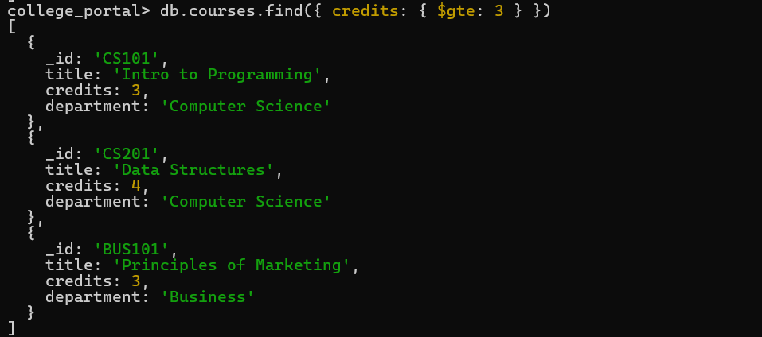
- Delete the `courses` collection (for testing) and then reinsert it.
Delete
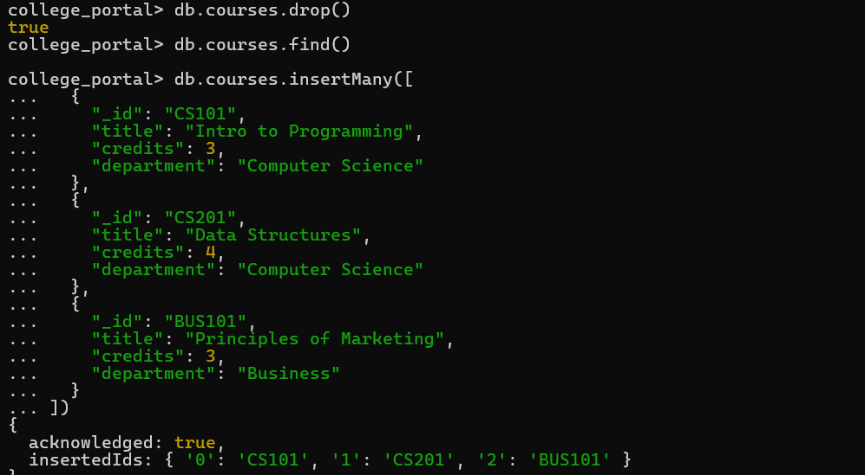

Reinsert
